Assignment 11.1

1. Return the categories (names) of the longest film. NOTE that there may be several "longest"
films (i.e. with the same length), so you might need to return more than one category. Return
the duration as well.
Use Sakila;
select title,max(length) from sakila.film
group by title
having max(length)=(select max(length) from sakila.film);

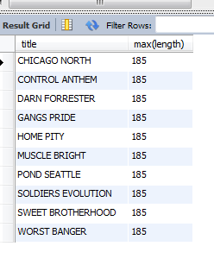

2. Find the movies whose total number of actors is above the average. Return the movie names
and its number of actors ordered by the title. IMPORTANT NOTE: this query should return many
movies. Please write in your submission only the first TOP-10 results.

select m.f_name, count(m.a_id)
from
(
select y.actor_id a_id, x.film_id f_id, x.title f_name
from sakila.film x , sakila.film_actor y
where x.film_id=y.film_id
) as m
group by m.f_name
having count(m.a_id) > (select avg(cnt) from
(
select film_id,count(distinct (actor_id)) cnt from sakila.film_actor group by film_id) as a_table
)
order by count(m.a_id) desc
limit 10;
